What Really Happened (http://www.whatreallyhappened.com/WRHARTICLES/bang.php)

**THE "BIG BANG" IS JUST RELIGION DISGUISED AS SCIENCE**

by Michael Rivero 1999

Let me preface this by saying I come from a science background myself, but all too often science gets hijacked and distorted for political or economic gain, or simply makes goofs which are perpetuated by arrogance!

Why should we not just blindly trust science?

Alchemy, for one.

Phlogiston Chemistry, for another.

Prior to the 14th Century Astronomers thought the Earth was the centre of the universe, because, well, that's what the church wanted, and spent hundreds of years of scientific research on the theory of Epicycles; which holds the record for longest running scientific goof!

17th Century doctors thought rubbing chicken dung into your scalp would cure baldness! They also thought leeches sucked disease out of patients.

18th Century Geologists thinking the Earth was 6000 years old, because, well, that's what the church wanted!

Prior to the 1950s, scientists thought proteins carried our heredity.

Until the 19th Century, doctors though infection was caused by bad air.

Scientists claimed cigarettes were good for you up until the 1950s. They even had a machine to pump tobacco smoke into your anus...

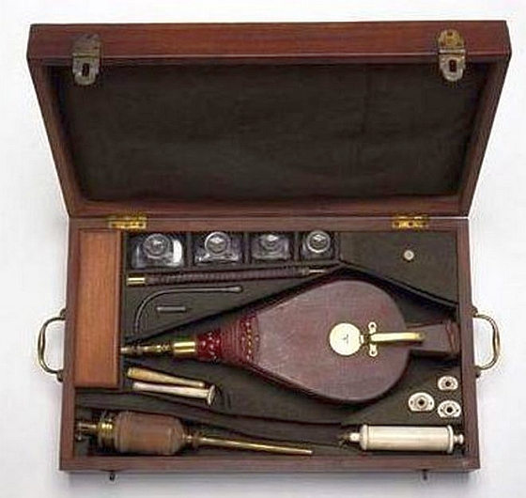  
... the origin of the phrase "blowing smoke up your a**!"

Until 2005, doctors thought ulcers were caused by stress.

National Geographic should not be questioning why people do not trust science after its own 1999 "Piltdown Chicken" scandal!

The beauty of science is supposed to be that they admit it, not use the label of "science" like a modern religious icon to push agendas onto people! Anyone who says the "Science is settled" is not being scientific, they are being propagandistic!

Once upon a time, a long time ago, there was this guy named Aristotle.

***Aristotle***

Pretty sharp fellow; he thought up a lot of good things. But, occasionally he made a mistake.

One mistake he made was to toss an orange up in the air and watch it come straight back down to his hand. Aristotle reasoned that if he was moving, the orange would have flown off to one side as soon as it left his hand. Because the orange did not do so, Aristotle concluded he was not moving. On the basis of this one observed fact, and the assumption that there was no other explanation for what he observed, Aristotle concluded that the Earth does not move and that therefore all of the rest of the universe had to move around it.

Aristotle was a very sharp guy, but the fact is that there was another explanation for why the orange fell back into his hand, and it would wait about another 2000 years before another smart man, Sir Isaac Newton explained just what it was Aristotle had overlooked, set forth in Newton's laws of motion; that both the orange and Aristotle's hand were moving together!

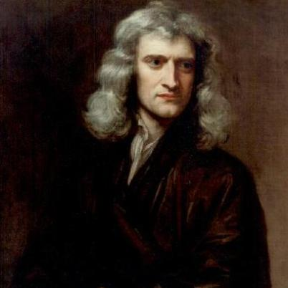***Newton***

But for the early church, Aristotle's conclusions fit in rather well with their theology, which had the Earth created as the center of the universe, unmoving, with the rest of the cosmos spinning about it.

[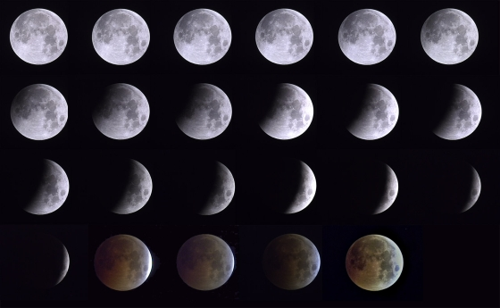](http://whatreallyhappened.com/IMAGES/BANGIMAGES/lunar-eclipse-wp-5.jpg)Of course, there was empirical evidence available to all that cast doubt on the church-approved version of the Cosmos. One could see during lunar eclipses that the Earth was not flat. The curved shape of the Earth's shadow as it crossed the moon was the same no matter which place in the sky the eclipse happened. The only shape that casts a curved shadow no matter what angle the light passes is a sphere!

Therefore a spherical Earth was the only shape that could produce a constantly curved shadow on the Moon. Aristarchus used the curve of the Earth's shadow on the Moon to estimate that the Moon was 1/3 the size of Earth, a remarkably accurate estimate considering the technological limitations of his time!

Ships sailing over the horizon clearly vanished over a subtle curve ( an observation which helped Columbus convince supporters of his voyages).



***A ship dipping below the horizon***

Then there was Foucault's Pendulum, a simple device of an unconstrained pendulum that swings back and forth, but over the course of the day changes the direction of the swing.

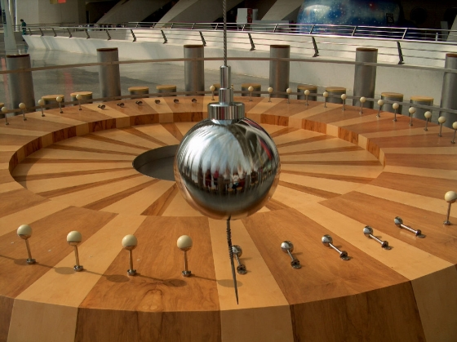

***A Foucault pendulum***

Nobody could explain the behavior of a Foucault's Pendulum other than by the Earth spinning beneath the swinging bob.

But by far the most troubling problem for the geocentric (earth centered) universe was the strange behavior of the planets. In an age before TV, or even books, the night sky was something every person was quite familiar with, even those who were not sailors or fortune tellers. Watching the night sky over time, the paths of the planets were easily seen to occasionally pause, move in reverse for a time, then proceed forward.

This behavior was called retrograde motion. Ah, but this was a problem. The church did not have an explanation for this behavior. Indeed in the King James Version of the Bible, the word "planet" appears only once, and then only as an object to be sacrificed to.



***Retrograde motion***

There is a very simple explanation for retrograde motion. As the Earth, moving in its inner orbit, overtakes an outer planet, the outer planet will appear to hesitate, briefly reverse its path across the sky, then resume its normal path.

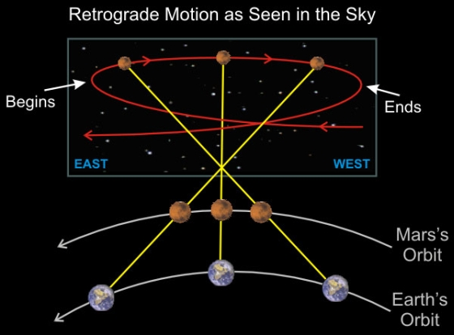  
***The cause of retrograde motion***

But the idea that the Earth moved was contrary to Church Dogma and to Aristotle. What education was tolerated by the church was "encouraged" to find some way to explain retrograde motion in a way that did not conflict with the religious needs for a universe centered on an unmoving Earth. Rather than re-examine Aristotle's basic claim, the learned men of the day grabbed onto a suggestion made by Claudius Ptolemy called "epicycles".

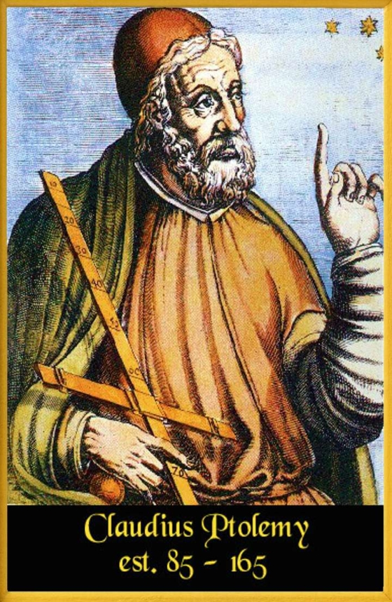

This theory explained retrograde motion around a motionless Earth by suggesting that the planets moved in large orbits called deferents, upon which were superimposed smaller orbits called epicycles which produced a "wobble" as seen from Earth.



***Ptolemy's theory of epicycles***

Epicycles were extremely popular with the church, and scholars at universities with religious affiliations were "encouraged" to refine this theory. And it needed refinement, badly, because the epicycle theory did not accurately predict what was being seen in the sky. Generations of effort was expended trying to figure out why the models did not predict the actual motions of the planets. At one point, it was even suggested that the epicycles had epicycles. No matter how many times the observed results did not match the predictions, the approved course of action was to refine the theory, but never to question the basic assumption of a cosmos centered on an unmoving Earth. Those who dared point to the evidence suggesting that Aristotle (and by extension the church) were in error in postulating a geocentric universe were "discouraged". Galileo was tortured into recanting his conclusions that the Earth moved. Giordano Bruno was burned alive at the stake for suggesting that the sun was really just another star, only close up, and that the other stars had their own planets.

The theory of Epicycles, kept alive by religion, politics, and torture, holds the record of the longest running totally wrong scientific theory in history!

In recent times, our expanding technology has confirmed that Galileo and Bruno were right, and Aristotle and the church were flat out wrong. The Earth does move. There are no deferents or epicycles, or even epicycles on the epicycles. The models of the universe which are based on a moving Earth are quite accurate and able to predict the behaviors of the planets as evidenced by the fact that we send spacecraft to those planets on a regular basis.

The theory of a geocentric universe and the theory of epicycles were not science. It was religious doctrine masked as science.

The church has never really dealt with the reality of the universe very well. They only apologized for their treatment of Galileo recently and still refuse to discuss Bruno. The Bible, presumed to be the perfect word of a perfect God, still teaches that the Earth is flat, rests on pillars (Job 26:11), and does not move (Psalms 19:5-6 93:1 96:10 104:5).

It seems that some mistakes are destined to be repeated again, despite our technological prowess.

In 1929, a Cal-Tech astronomer named Edwin Hubble observed that objects which appeared to be much further away showed a more pronounced shift towards the red end of the spectrum.

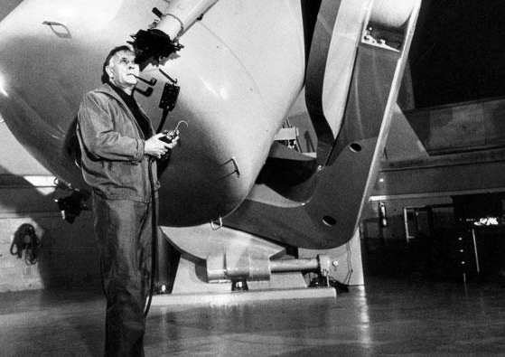  
***Edwin Hubble at Palomar***

Scientists building on Hubble's discovery assumed that the observed red shift was from doppler effects caused by motion, and concluded that the farther an object was away from Earth, the faster it was receding. They calculated the relationship between distance and velocity, called the "Hubble Constant" and concluded on the basis of this one observed fact and the assumption that there was no other explanation for the observed red shift that the universe was expanding. Aristotle's orange had been reborn!

  
***Red shift as a function of distance***

Religious circles embraced the idea of an expanding universe because for the universe to be expanding, then at some point in the past it had to originate from a single point, called the "Big Bang". Indeed, the concept of the Big Bang did not originate with Edwin Hubble himself but was proposed by a Catholic Monk, Georges Lema'tre in 1927, two years before Hubble published his observations of the Red Shift.

The "Big Bang" coincided nicely with religious doctrine and just as had been the case with epicycles (and despite the embarrassment thereof) religious institutions sought to encourage this new model of the universe over all others, including the then prevalent "steady state" theory. In 1951 Pope Pius XII declared that Georges Lema'tre's work proved the Christian dogma of divine creation of the universe.

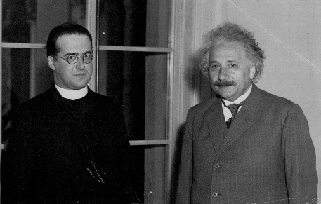

***Georges Lema'tre with Einstein***

Then history repeated itself. Evidence surfaced that the "Big Bang" might not really be a workable theory in the form of General Relativity, and its postulation that super massive objects would have gravity fields so strong that even light could not escape, nor would matter be able to differentiate.

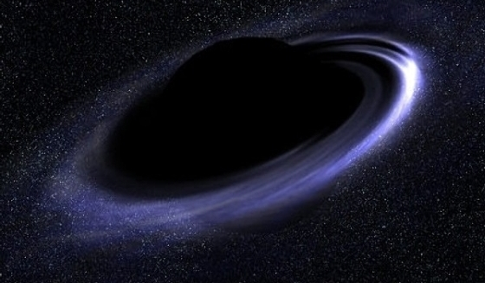

***A black hole***

Since the entire universe existing in just one spot would be the most super massive object of all, the universe could not be born.

Needless to say, this suggestion that the Big Bang could not happen provoked the same exact reaction as the suggestion that the Earth might not be the center of everything. Instead of questioning the basic assumption, great effort was made to find a way to evolve the new data in terms acceptable to the assumption of a universe spawned in a single moment of creation. A complex Cosmology theory sprang up, encouraged by those invested in the "Big Bang" to explain why the basic foundational principles of physics behaved differently in the first few milliseconds of time. The math work is impressive, as impressive as that which supported the theory of the epicycles, but it is really just a polite way of saying "The rules just didn't apply when we need them not to apply", i.e. a "miracle" happened.

An attempt was made to prove the Big Bang by searching for the "Cosmic Background Radiation", the presumed energy echo from the primordial explosion, and indeed a radio noise signal was picked up. Like Aristotle, and like Lema'tre, the discoverers of the Cosmic Background Radiation assumed the signal meant what they thought it did and could have no alternative explanation.

The discovery of the Cosmic Background Radiation was then heralded as final proof of the Big Bang theory, and those institutions invested in that theory (and rewarded thereby) celebrated.

But just as the theory of epicycles did not accurately predict the observed motion of the planets, the Big Bang Theory turned out to be less than accurate about the radiation signal detected in space.

For one thing, there is the "Horizon Problem". At present, the known universe spans 28 billion light years and is assumed to be 14 billion years old. (Obviously unless we actually ARE the center of the universe, it may be assumed that the universe probably extends even further in at least one direction).

Nothing can travel faster than the speed of light, so there is no way heat radiation could have traveled between the two horizons to even out the hot and cold spots created in the big bang and leave the thermal equilibrium we see now.

When the satellite COBE was sent up to analyze the Cosmic Background Radiation, it discovered instead of the smooth featureless glow predicted by the cosmologists a highly complex and detailed structure.

Yet again, rather than question the prime assumption that the signal being analyzed was actually from a supposed "Big Bang", research was encouraged to find a way to fit the data into the existing theory, again on the assumption that the signal detected could not be from any other source. And yet, an alternative explanation for the signal was right at hand, indeed literally on all sides.

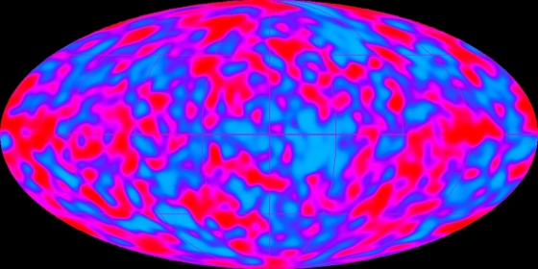

***The Cosmic Background Radiation?***

Our Solar System and planets have heavy elements (without which you would not be here) because at some time prior to the creation of our Solar System another star in the immediate vicinity exploded, creating the heavy elements and scattering them into the universe. Every star that explodes creates a planetary nebula, such as the one easily seen with amateur telescopes in the constellation Lyra. A planetary nebula is a bubble of debris in space, and given the presence of heavy elements in our own Solar System, then somewhere out in space there must be the tenuous remains of a billions of years old planetary nebula, the result of a not-so-very-big bang close by, viewed from our unique point of view very near the center.

This model of Earth lying at the center of the remains of a supernova predicts exactly the sort of structure that COBE found in the presumed Cosmic Background Radiation. But as was the case with Galileo and Bruno, challengers to the "approved" creation myths face a tough time, albeit funding cuts have replaced torture and being burned alive at the stake, as anyone questioning the dogma of human-caused global warming can attest.

**UPDATE: BIG BANG EVIDENCE STARTS TO CRUMBLE**

[A dusty mistake? 'Groundbreaking' Bicep2 Big Bang signal was just interstellar debris in the galaxy, scientists reveal](http://www.dailymail.co.uk/sciencetech/article-2933137/A-dusty-mistake-groundbreaking-Bicep2-Big-Bang-signal-just-interstellar-debris-galaxy-scientists-reveal.html)

So pervasive is this bias to see the universe as created in a Biblical-consistent "Big Bang" that when William G. Tifft submitted his first article on the quantization of the observed Red Shift to Astrophysical Journal, the Journal published it because they could not find errors in it, yet still felt compelled to editorially distance themselves from the conclusions.

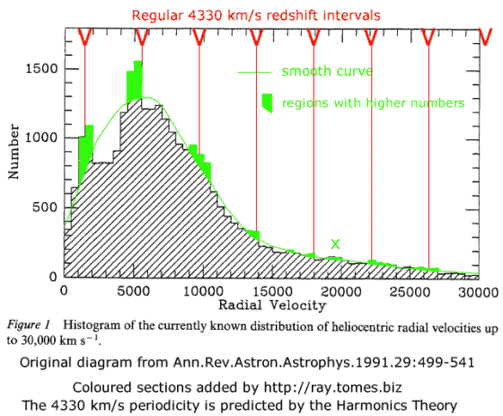

***The quantized red shift***

The conclusions derived from quantized red shift are devastating to the conventional view of the universe created in a single Big Bang, as devastating as Galileo's first telescope was to the theory that the Earth was the center of the universe.

Georges Lemaître (like Aristotle) assumed there was no other explanation for the red shift he observed than the motion of the observed objects relative to Earth. But given the theory that the universe is expanding uniformly, the amount of red shifts would have to be uniformly and randomly distributed.

But they aren't.

The observed red shifts in the sky are quantized, falling into discreet intervals. This is not explainable by the theory that the red shift is produced solely by relative velocity as the distances to remote objects are uniformly distributed. Some other effect must be at work. And that means that the assumption that the universe is expanding based solely on the red shift is invalidated. Some other effect IS at work that explains the observations, quite possibly one that triggers a quantized red shift over vast distances without respect to relative velocity.

Which means the universe is not expanding. Which means there was no moment of creation, no "Big Bang" with an epicycle-esque cosmology to explain why the greatest black hole of all didn't behave like a black hole. Which means that the background radiation mapped by COBE which didn't quite fit the Big Bang model is probably the remnant of the stellar explosion that created the heavy elements making up that computer you are reading this on.

But the lesson for our time of just how much our society remains dominated by religious superstitions is revealed by the fact that the quantized red-shift is NOT a new discovery. The first article regarding the observed data appeared in 1976, a quarter of a century ago. Since then, scientists as much in the service of superstition as were those scientists who "studied" epicycles have repeatedly tried to disprove the observations of Tifft and Cocke, only to confirm and re-confirm the truth, that there is a quantized red-shift, which casts doubt on the theory of an expanding universe and a "Big Bang" creation.

Yet even though hard evidence exists to warrant a full re-examination of the basic assumption of the expanding universe, our science classes and TV programs still promote the "Big Bang" view, just as the erroneous theory of Aristotle continued to be promoted even after Galileo proved it wrong, because one theory fits into a theology, and the other does not.

Man's progress is not measured by the reaches of his science but by the limits of his superstition. The truth is known. But the truth is unpopular.

The assumption that there must be a beginning to the universe is merely a human invention. We believe that we see things have beginnings and ends before us, but in truth we are seeing matter change form. A particular configuration may have a beginning and an end, but that actual matter and energy cannot be created or destroyed is an axiom of physics. Miss April may be only 20 years old, but the atoms in her heavenly body are indeed heavenly bodies, being the remains of ancient exploded stars, and in THAT form for billions of years.

Ancients believed that the Earth was the center of the universe. But while we grudgingly admit that Earth orbits the sun and that our sun is nowhere near the center of the milky way, the idea that Earth is the center of all remains at the heart of the assumptions of the Big Bang theory. The "Bangers" describe the furthest objects we can detect (currently 13 billion light years) and from that calculate the age of the universe (currently set at 14 billion years).

But that only works if we ASSUME that the Earth is the center for all the cosmos that we can see. It is true that we are seeing objects out to the edge of our technological limits and we are seeing them in all directions. We do not see an obvious end to the universe. Logically, the odds are far greater than what we can actually see is really just a tiny bubble in a far larger universe, rather than we just happen to be that one in googleplex2 worlds that wound up at the exact center for the expanding field of debris from the Big Bang (i.e. the location of the original singularity). And if we abandon the assumption that we see most of the the universe from a fortunate position near the location of the original singularity, then we cannot really know how large the universe really is, and the mathematics by which we claim to know the age based on the size break down completely. We truly are trying to calculate the number of angels that can dance on the head of a pin.

**PROOF THE BIG BANG DID NOT HAPPEN - THE SINGULARITY**

  Perhaps the biggest contradiction with the Big Bang Theory is the question of the singularity. The "primordial egg" had to be a super-massive black hole. Therefore no amount of "bang", no matter how big, is going to thrust the universe out into, well, the universe.

  Cosmologists eager to promote the Big Bang Theory have hit upon the "explanation" that the laws of physics, gravity., etc. simply did not apply in those first few moments of the universe. The present Cosmology theory is that the universe enjoyed a period of "rulelessness" of about  3 seconds, after which the elements formed and the fundamental forces of the universe, gravity included, were functioning as we see them today. It is quite interesting to see the entire body of established physics put on hold for the convenience needed to support the Big Bang!

Ah, but there is a problem with this three second period of rulelessness. The singularity formed by the primordial egg turns out to be rather large.

Estimates of the total mass of the universe vary wildly, given that the ends of the universe have not yet been determined. One estimate is found at  http://people.cs.umass.edu/~immerman/stanford/universe.html of 1.3e52 lb. Written out longhand, that is 130000000000000000000000000000000000000000000000000000 pounds!

From the mass, you can calculate the diameter of the event horizon by finding the distance from a point mass that will have an escape velocity of c. Use sqrt(2GM/r) where M is the mass of the hole (the entire universe in this case) and r is the radius (classical), and G is the gravitational constant. Work it backward starting at c and you get c^2=2GM/r. This works out to an event horizon light years in size!

In short, at the moment in time when the Big Bang theorists claim the universe was functioning as it does today, complete with all fundamental forces, the entirety of the universe's mass was still well within the event horizon of its own gravity well. That the well was not the product of a true singularity is irrelevant, Newton's equation provides an equivalent gravity field for a singularity or a super dense mass in a localized region.

Therefore the Big Bang, as currently described, could not have produced the universe as we see it today. At three seconds, the time the theorists claim the universe started operating as we know it, it would have come under the influence of its own gravity and unable to reach an escape velocity exceeding that of light, would have collapsed back into itself.

The "Bangers" got around this paradox with the theory that when the universe was created, it had no mass at all. Therefore, so the theory goes, there was no gravity and no reason the the bang matter (or "batter") not to escape the bang into the universe. Then, after the matter was conveniently far away from the singularity, it interacted with a particle named the Higgs Boson. Like the two tubes that come with epoxy, the Higgs Boson blended with the massless "batter" and produced normal matter with mass. How all the matter in the universe knew just when to mix the tubes together is still open to speculation, but usually the proponents of this theory start whispering about God under their breath at this point.

After more than a few false alarms, CERN now claims to have found the Higgs Boson. The Large Hadron Collider at CERN was built specifically to look for the Higgs Boson, nicknamed "The God Particle", thereby revealing the religious agenda that is actually behind what may be history's most expensive church. It must be pointed out that although the LHC, in the unimaginable fury of the high energy collisions it generates, claims to have succeeded in producing a particle that more or less matches the predicted characteristics of the Higgs Boson (absent a piece of "massless matter" to test it with, how will we know?), that does not prove such a particle ever existed before that very moment, nor does it prove the Big Bang. The scientist-priests at the LHC will not be able to prove that their new particle is not itself a creation of the LHC rather than a part of the natural atomic world.

Particle physicists like to joke that studying matter with colliders is like smashing two mechanical clocks together and trying to guess what the clocks looked like based on the springs, gears, and levers that fly out. Let us take that analogy one step further and speculate that given enough speed at the moment of collision, individual teeth from the clock gears will come flying out as separate distinct pieces. But clearly, prior to that moment of collision, they never did exist as separate distinct pieces. Their separateness is created by the collision at that very moment. The same may well be true of the ultra-tiny particles generated by the collisions of the LHC, including whatever we may be asked to accept on faith as the "God Particle." They may be artifacts of the experimental method, and not of natural processes.

**ANOTHER PROOF THE BIG BANG DID NOT HAPPEN - POPULATION II STARS**

For the purposes of this thought experiment, let us assume that God waved a magic wand and the universe popped into existence from a Big Bang, and that "somehow" the universe escaped from it's own gravity well. With the entire 1.3e52 lb mass/energy of the universe confined to that small region, the temperatures and pressures amount to a super-supernova. We already know that in the cataclysm of a supernova, the heavier elements are created. That is where all the heavy elements in your body were created; inside an exploding star. Therefore, in that moment of super-creation called the Big Bang, as the universe started to operate by the rules we know today, the expanding universe should be creating all the known heavy elements.

So, how do we explain the Population II stars?

Population II stars are stars with no heavy elements in them. When they explode at the end of their life cycles, heavy elements are created. These are swept up by stars that form afterwards creating Population I stars, usually with planets around them. Population I stars have heavy elements. Population II stars do not. (The numbering was given before the time sequence from Population II to Population I stars was understood.)

If the Big Bang had happened, the universe would be filled with heavy elements created in those first few moments the universe started to operate under the rules of physics we know today. There should not be any stars in existence devoid of those heavy elements. And yet there are.

The existence of Population II stars, devoid of heavy elements, directly contradicts the theory of the Big Bang.

**YET ANOTHER PROOF THE BIG BANG DID NOT HAPPEN - LOOKING OUT INTO THE UNIVERSE MEANS LOOKING BACK IN TIME**

The Big Bang is currently imagined to have occurred 14 billion years ago.

The farthest object seen in the sky by the Hubble and Keck Telescopes is 13 billion light-years distant, and is assumed to have been created when the universe was just 750 million years old. It would take at least that long (if not longer) for the material from the theorized Big Bang to coalesce into stars and for those stars to form a rotating galaxy.

But here is the problem. We are seeing that object 13 billion light-years distant not as it is today and where it is today but as it was and where it was, 13 billion years ago, 13 billion light-years distant from earth.

In other words, for this galaxy to lie 13 billion light-years away from Earth only 750 million years after the Big Bang, it would have had to travel 13 billion light years in just 750 million years' time. That requires the galaxy in question to travel more than 17 times faster than the speed of light, a speed limit which according to the Big Bang supporters was in effect from the moment the universe was 3 seconds old.

**ANOTHER PROOF THE BIG BANG DID NOT HAPPEN - ENTROPY**

The Big bang violates the Second Law of Thermodynamics. That law states that the universe inevitably flows towards maximum entropy. Yet the singularity that produced the Big bang, with all the matter and energy in the universe contained in a single dimensionless point, was already at maximum entropy.

**ANOTHER PROOF THE BIG BANG DID NOT HAPPEN - AN INTRIGUING QUESTION**

We see in the night sky that all galaxies rotate. Stars rotate. Planets rotate. Bodies orbit around other bodies. A dimensionless singularity posited by the Big Bang cannot have rotation. So where did all this angular momentum come from if the universe emerged from the Big Bang singularity? For that matter, how do we get a variation in velocity or density emerging from a singularity?

UPDATES: In 2011, the Large Hadron Collider at CERN was finally switched on in the experiment it was built to carry out; to prove the existence of the Higgs Boson, the hypothetical particle necessary to reconcile the Big Bang with Special Relativity. CERN concluded that the Higgs particle did not in fact exist, then reversed their conclusion 2 years later. The 2011 Nobel Prize in physics went to three American scientists who demonstrated that the rate of expansion in the expanding universe is accelerating. Even taken at face value, this means some other force is at work other than the initial impetus of the supposed moment of creation. Something else is being seen and possibly misinterpreted! It is time to question the prime assumption that the observed red shift in the sky is attributable only to relative velocity.

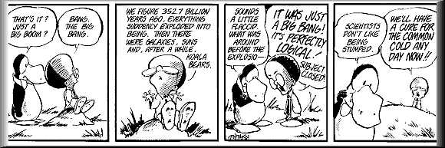

**AN EMBARRASSING FACT**

Astronomers keep discovering objects older than the presumed moment of the Big Bang. Rather than see those objects as evidence that undermines the theory of the Big Bang, cosmologists simply push the date of the Big Bang (and the estimated size of the universe) back further.

**MORE EPICYCLES**

As more problems surface with the theory of the Big Bang, more and more "interesting" workarounds appear, including the theory that while objects within space cannot travel faster than light, space itself can grow in size faster than light (to deal with some of the observations noted above). Then there is the theory of Dark Matter, created to satisfy discrepancies in the math used to model the epicycles, but like the Higgs Boson, not actually proven to exist (although they claim to be 99% of the way there). However, other scientists are already pointing out that General Relativity itself may be problematic, and Einstein's original model is being revised to eliminate the need for Dark Matter.

A PICTORIAL HISTORY OF REALLY EXPENSIVE (AND FAILED) ATTEMPTS TO CONNECT WITH THE GODS!

Each of these constructions you see below represented the most advanced technology available at the time of their construction. All were created for the same purpose; to link directly to the gods.   
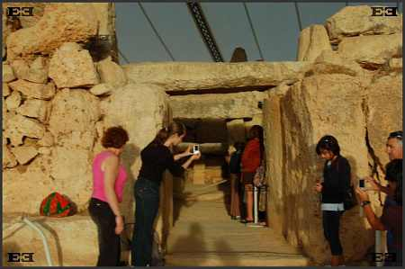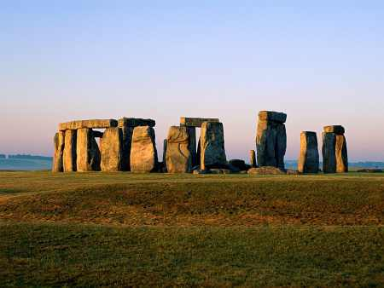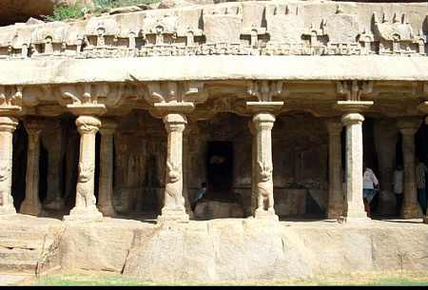  
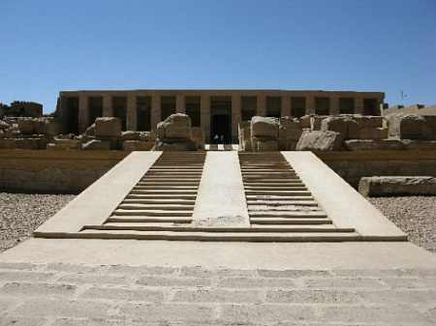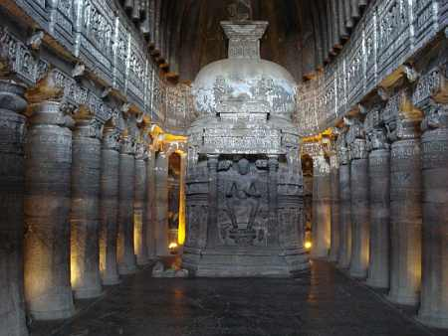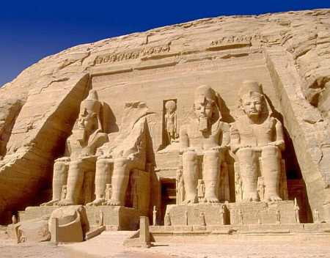  
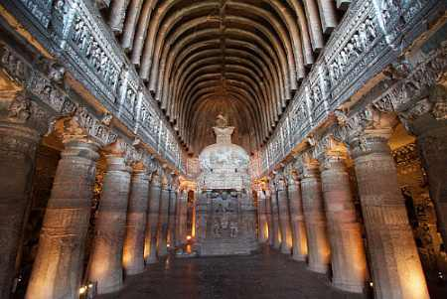  
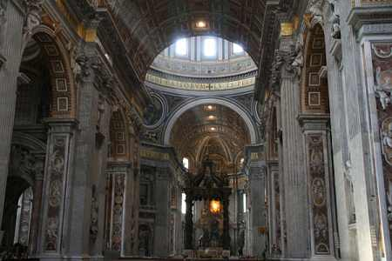  
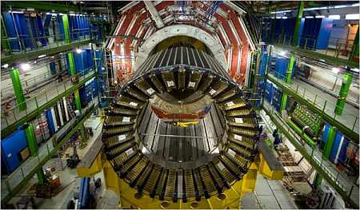

**A FOOTNOTE**

Needless to say I have received a huge amount of email regarding this article (and other speculations). Virtually all the supporters of the Big Bang theory point to my lack of advanced college degrees in the necessary subjects as "proof" that I cannot possibly know what I am talking about. However, while scientific method is a valuable tool for determining the truth, history has shown that institutionalized and commercialized science is often as dogmatic as religion, with advanced degrees awarded to those students who have proven an unflagging adherence to the assumptions of the past. It was for that very reason that the theory of Epicycles lived to a ripe old age. We see the same phenomenon in action today as academics eager for funding continue to promote the theory of human-caused global warming, despite several recent record-setting winters! Each new student has to first show adherence to established theory in order to progress to the higher levels of education and funding.

History is ripe with examples of people who achieved great scientific breakthroughs without advanced degrees because they were free to explore the "unacceptable" possibilities. Albert Einstein developed his Theory of Relativity while working as a patent clerk, and only attended graduate school afterwards. Bill Gates quit college to build computers. So did Steve Jobs. Mark Zuckerburg quit Harvard to found Facebook. Thomas Edison had almost no formal education at all. Walt Disney dropped out of High School.

I would like to share an anecdote from my own educational career. I attended Cal-State Fullerton's theater department, having been lured to enroll based on advertising proclamations of past graduates who had succeeded in professional careers in film making. In my fourth year, I took a class on theater history which required a term paper. For my term paper I chose theater technology and wrote the paper in three chapters. Chapter 1 was theater technology prior to the American influence, focusing on gas lights, lime lights, and so forth. Chapter 2 was the American contribution to theater technology, with the obvious focus on electric lights and the peripheral devices to control them such as autotransformers, SRC dimmers, pre-set boards and so forth. For chapter 3 I called on my prior experience in aerospace to predict that small affordable computers would change the face of theater and also film and television with computer controlled lighting systems, audio, flying rigs, and ended by suggesting that computers would one day put photo-real images onto film and video tape. My professor called chapter 3 a load of nonsense and flunked me on the basis that the third chapter did not have footnotes. How could there be footnotes when this was all technology yet to be developed? I took my case to the department chairman and argued that if Cal-State Fullerton were preparing their students for professional careers it would be wise to predict what those careers might actually entail. the Chairman informed me that while the occasional happy occurrence of an alumni actually having a professional film career was eagerly used as a recruitment tool, in actuality the department was all about creating new theater teachers, not working professionals. At that point, having clearly wasted some years of my life, I walked out of the department.

There is a happy footnote to that story. I took my term paper and showed it to a friend who knew someone at CBS Television City, which promptly hired me to help design and build the first generation of computer-controlled game show scoreboards!